 | Year 11 Methods  Term 3 Week 6 Quiz | $$\frac{}{45}$$

Name: __________________
- Match the graphs of functions I, II, and III to the graphs of their derivatives A, B, and C. (3)
I. A.

II. B.

III. C.

I,C II,B III,A

- The graph of the derivative of f(x) = 2x + 3 is (1)
a. a horizontal line b. a vertical line c. a line with a positive slope d. a line with a negative slope
a.
- The derivative of has the equation (1)
a. x = 0 b. y = 0 c. d. e. y = 5
d.
- The graph of the derivative of is (1)
a. a horizontal line b. a vertical line c. a line with a positive slope d. a line with a negative slope
c.
- If $f\left(x\right)=2x^{2}-x+3$ , the value of x at which the gradient of the curve is 1 is: (1)
a. 3 b. $-\frac{1}{4}$ c. $-\frac{2}{3}$ d. $\frac{1}{2}$ e. 0

a.
- Find the average rate of change of $y=x^{2}-3x$ between x = 1 and x = 3. (2)
- Find the equation of the tangent to the curve $y=x^{3}$ at x = 2 (3)
- Find the instantaneous rate of change of the function $f\left(x\right)=x^{3}-3x^{2}+4x$when x = -2. (2)
- The graph below shows the derivative function, $h'(x)$ of a function $h\left(x\right):$ (1)
From this graph, we can conclude that:
A. The graph of $h\left(x\right)$ has a stationary point at x = 3.5
B. The graph of $h\left(x\right)$ has a maximum turning point at x = 5
C. The graph of $h\left(x\right)$ has a minimum turning point at x = 2
D. The graph of $h\left(x\right)$has a maximum turning point at x = 2
E. The graph of $h\left(x\right)$has a stationary point of inflection at x = 3.5

- Use first principles to find the derivative of the function: $f\left(x\right)=3x^{2}-6x$ (2)

- State the solutions of the equation (x - 2)(x + 3)(x - 4)(x + 5) = 0. (1)

x = 2, -3, 4, -5

- Give the sequence of transformations which transforms the graph of y = x³ to the graph of y = 3(x - 1)³ + 2.
Horizontal translation 1 unit right (3)
Vertical stretch of scale factor 3
Vertical translation 2 units up

- For the given points A(-2, 3) and B(-1, -4): (6)
a. find the midpoint (M) of A and B
M = [1 mark]
=
= [1 mark]

b. find the distance between A and B
[1 mark]
= units [1 mark]

c. find the gradient of line AB.
[1 mark]
= −7 [1 mark]

- Find the radius and the coordinates of the centre of the circle x² + 4x + y² - 6y - 12 = 0. (4)
x2 + 4x + y2 − 6y = 12
x2 + 4x + 4 + y2 − 6y + 9 = 12 + 4 + 9 [1 mark]
(x + 2)2 + (y − 3)2 = 25 [1 mark]
This is in the form (x − a)2 + (y − b)2 = r2
Radius is 5 units. [1 mark]
Centre is (−2, 3). [1 mark]

- The first and fifth terms of a GP are 5 and 3125 respectively. What is S5 for this sequence? (2)
t5 = 5 × r4 = 3125
∴ r4 = 625, r = 5 [1 mark]
[1 mark]

- If sin (a) = and cos (b) = , find the exact value of cos (a + b) (5)
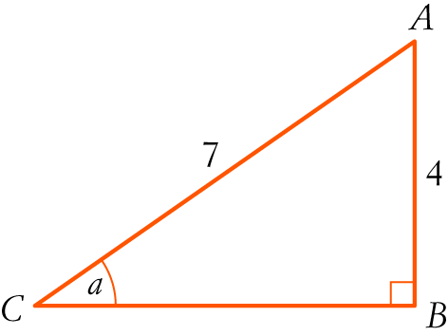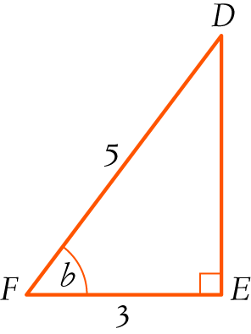
CB2 = 72 − 42 = 33
CB = [1 mark]
DE = 4 (3-4-5 triangle) [1 mark]
cos (a + b) = cos (a) cos (b) − sin (a) sin (b) [1 mark]
= [1 mark]
=
= [1 mark]

- Solve the following: (6)
- $5^{3x-8}={25}^{2x}$
$5^{3x-8}={(5^{2})}^{2x}$
$5^{3x-8}=5^{4x}$
$3x-8=4x$
$-8=x$

- $3^{2x-1}={27}^{x}$
$3^{2x-1}={(3^{3})}^{x}$
$3^{2x-1}=3^{3x}$
$2x-1=3x$
$-1=x$

